Conjecture:
4 does not divide (a² + 2)

ChatGPT proof by contradiction:
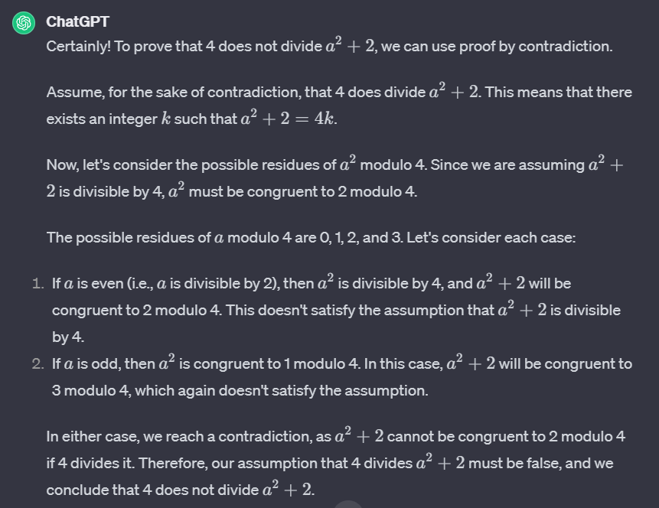

Validation:
Yes, ChatGPT used a valid method as well as deriving the proof from the basis of definitions and logical mathematical steps. It could have been more thorough with some of the rules it uses since it simply states that they are facts, even though they aren’t axioms of definitions.

ChatGPT direct proof:
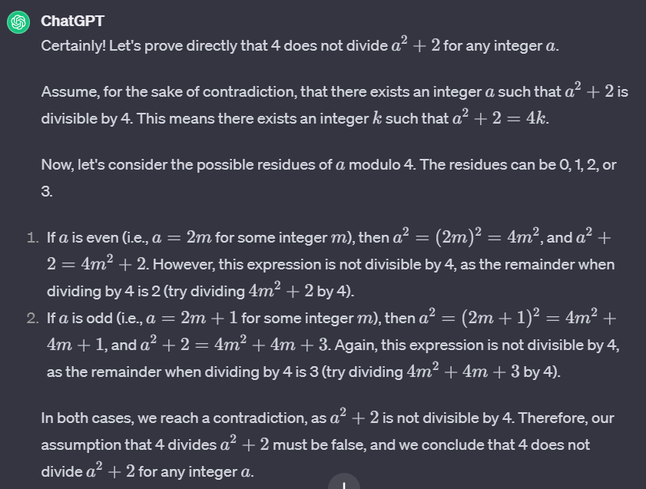

Validation:
This proof is better since it does not make any unproven assumptions. It still uses definitions and logical steps to prove an easily understandable and correct conjecture.

